Principal  J E Read - B.Ed.,  Adv. Dip., PQH (NI)  Tele: 028 6862 1408  Fax: 028 6862 8946 | 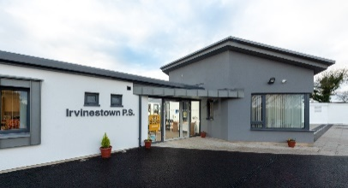 | 24 Burfits Hill  Irvinestown  Co Fermanagh  BT94 1DY
Email - info@irvinestownps.enniskillen.ni.sch.uk
Website - www.irvinestownps.co.uk

MAY NEWSLETTER 2022
Dear Parents,

Welcome back to a new summer term. Please remember summer uniform can now be worn. Please check that all jumpers are named as during the better weather these are often removed during the school day. Please note girls should not wear tights with the summer dress – white socks please.

SUMMER UNIFORM
All pupils have the option of wearing a Summer Uniform from 1st April to 30th September.

Boys:- Sky blue polo shirt with school logo
Navy blue v-neck sweatshirt
Grey long or navy/grey short trousers
Plain grey or navy ankle/knee length socks
Dark shoes/sandals with non-black soles

Girls:- Sky blue polo shirt with school logo
Navy blue v-neck sweatshirt
Dark grey skirt or pinafore or navy/grey shorts
Blue check summer dress
Plain white ankle/knee length socks
Dark shoes/sandals with non-stick soles

We understand some children may have school shoes that are becoming too tight. We do not expect parents to purchase new shoes at this stage of the year, so any sturdy shoes will be acceptable, however this is not an excuse for not wearing shoes that still fit. If they fit, please wear them. If not – an alternative is acceptable.

Please ensure that your child has a coat with a hood with them to school every day. All children go outside to play every day unless there is torrential rain.

MILK MONEY AND CONTRIBUTION
Milk money is now due for this term. Please pay £9 as soon as possible. Some families have still not yet paid their school contribution for the 2021-2022 school year. £20 for 1 child, £25 for 2 and £30 for 3 or more children. Please pay as soon as possible.
If you can’t remember if you have paid, you can check privately with your child’s teacher on your digital platform or ring Mrs Stewart in the office.
Please endeavour to send dinner money on the first day of the school week.

CORE KIDS

Core kids will be in school every Tuesday lunch time to provide fun activities for each class. Please ensure your child has trainers with them on Tuesdays.

SHARED EDUCATION

We would like to find out your views on our Shared Education programme which we hope to resume next year. Please complete the google form https://forms.gle/rPh4vmQrULLHHwpc6 before Tuesday 10th May 2022. Thank you

TRANSPORT APPLICATIONS
Applications for transport assistance to all schools, primary and post primary should be completed online via the EA website at https://www.eani.org.uk/financial-help/home-to-school-transport/transport-online-applications -See dates below.

Eligibility for transport assistance to mainstream schools is based on the distance from the pupil’s home to the school at which they have been offered a place or currently attend. The qualifying distance is two miles or more for Primary, measured by the shortest available walking route door to door.
All transport applications must be made online through the EA website.

Please note the online transport application process for September 2022 applications will open for:
- Primary Applications from Monday 9th May 2022
- Post Primary Applications from Tuesday 24th May 2022
You are not required to reapply each year unless there is a change in circumstances.
DINNER MENU
Please see attached dinner menu. Some minor changes have been made. This new Menu will begin on Monday 9th May.

FIRST AID

Don’t forget our First Aid training on Wednesday 4th May at 7pm. There are still a few spaces available. Please use the google form https://forms.gle/rFAZG4r8mKrVvauk8 if you would like to attend. I would really like if we could fill the 10 places available – at the minute I have 3 spaces left. First Aid knowledge is an extremely worthwhile skill and we never know when we may be called upon to use it.

END OF YEAR CELEBRATION EVENT
An end of year celebration has been planned for Thursday 16th June for Y7 and their parents at 10am. The Year 7 children are going to put on a show, which will be professionally recorded and available for you to purchase at £10 per DVD. Due to limited space we ask that no more than 2 people attend from each Y7 family.

Cups received last year at Prize Day should be returned to school no later than Wednesday 27th May. Please ensure you have these engraved. If the cup was shared, ensure both names are engraved on the cup.

SPORTS DAY
We are planning to have a Sports Day on the 7th June. We will be running races in our class bubbles. Y1-3 will run their races between 9.15am and 10.30am. Y4/5 will run their races between 11.00-12.30 Y6/7 will run their races from 12.45-2.45pm. Parents may come to watch their child/children. Please bring your own deckchair to sit on and wear a mask if so desired. Please try to keep to your own social bubbles as far as possible. – Teachers will let their classes know what they need prior to this event.

AQE

The AQE tests are to go ahead next year. There has been no notice from Mount Lourdes or St Michael’s about whether they will return to using GL as of yet.
The dates of the three assessments are 19/11, 26/11 and 3/12 2022.
The cost to parents is £60.
Applications will open on Wednesday 4th May 2022 and will close on Friday 23rd September at 4pm. The provisional date for results will be Saturday 4th February 2023. Full details can be found on the website www.aqe.org.uk

POST PRIMARY SCHOOL CHOICE

The present Y7 will be able to find out if they have been accepted to the school of their choice by logging in to the online portal on the 21st May 2022. https://www.nidirect.gov.uk/articles/transfer-post-primary-school#toc-6

THE QUEEN’S PLATINUM JUBILEE.

Our school has been successful in achieving a grant to take part in the Big Jubilee Summer fair project and we hope to have a special day of fun and celebrations on Wednesday 1st June prior to the long bank holiday weekend. More details will follow about what is planned for this event.

Kesh and District Platinum Jubilee committee have also asked me to draw to your attention events taking place over the Bank Holiday weekend. These include The Great Big Jubilee Bake off and The Best Jubilee Crown. There will be lots of fun activities like face painting, birds of prey display, bouncy castles, magic shows etc planned on Mantlin Park Playing Fields on Saturday 4th June. Please see the flyer at the end of this newsletter.

CONGRATULATIONS
Mrs. Hunter our school building supervisor travelled to Hillsborough Castle in April to receive her B.E.M from Viscount Brookeborough. We are delighted and offer her our sincere congratulations on receiving this special honour.

CASH FOR CLOBBER
We are having another collection for Cash for clobber on Thursday 19th May.
Please fill sturdy bin liners with unwanted items and bring your bags into school either before 9.15 am on Thursday or the afternoon before. Items such as old clothes, bed clothes, curtains, towels, shoes and coats are all acceptable.

STANDARDISED TESTS
During this month of May, standardised tests will be taking place from Year 2 to Year 6. Please try to ensure that children do not have any unnecessary absences.

Y1 INDUCTION
To accommodate next year’s Y1 induction programme we are sending Year 1 and Year 2 home early on the following Wednesday afternoons in June – 8th, 15th and 22nd. They should be collected at 1p.m. If you have any difficulty with this arrangement, please let me know as soon as possible. There will be dinner as normal on this day.

TENNIS
Please see the flyer regarding availability of Tennis Coaching at the Bawnacre

ADHD SUPPORT SESSIONS

Please see Flyer regarding 2 training support sessions and virtual support groups for parents of children with a diagnosis of ADHD provided by Parent Line.

Dates for your Diary
SUMMER TERM
Parent First Aid | Wednesday 4th May at 7pm
Y7 Lisnarick Trail Opening | Thursday 26th May at 9.45-12 noon
JUBILEE DAY | 1ST JUNE
May Bank Holidays | 2nd & 3rd June
Staff training (Pupil holiday) | 6th June
Sports day | 7th June
Y1 Induction  (Y1 and Y2 go home early) | 8th, 15th 22nd June
Prize day | Thursday 16th June 10am
Last Day of Term  School closes early | 30th June

Yours Sincerely,

Janice Harron

J Harron (Mrs)
Vice Principal

Dinner menu

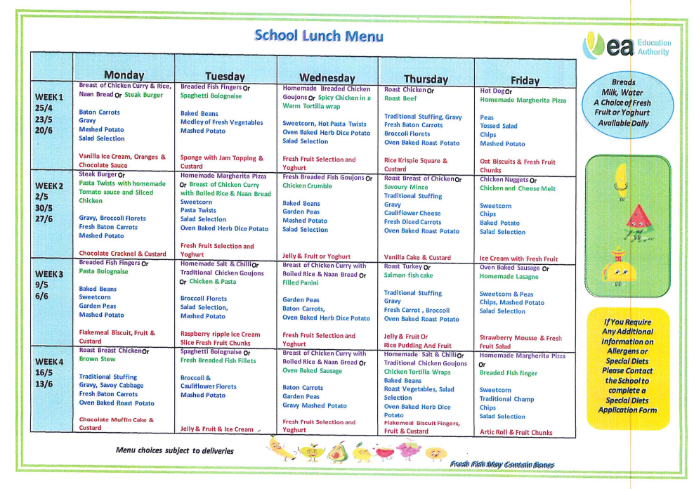
Tennis Coaching

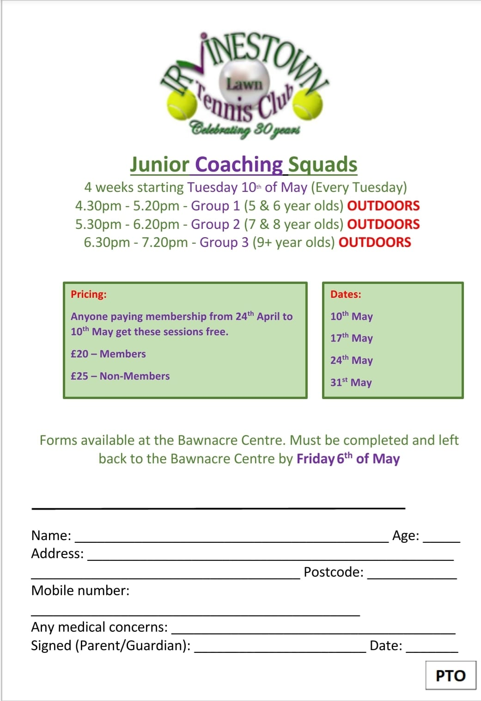

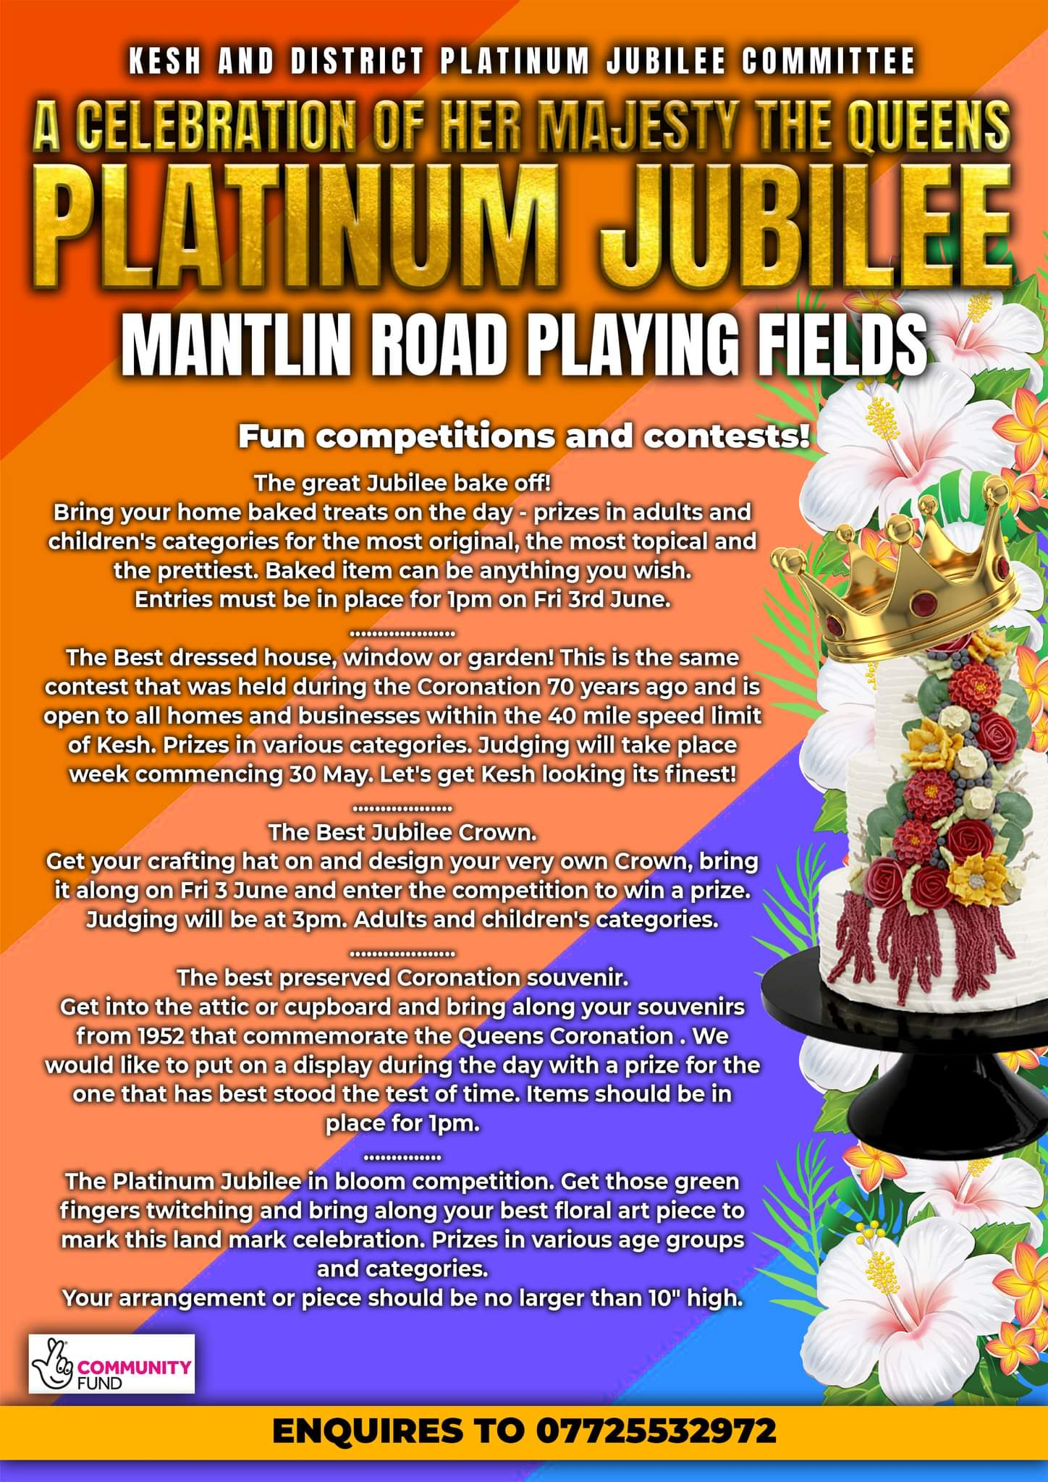
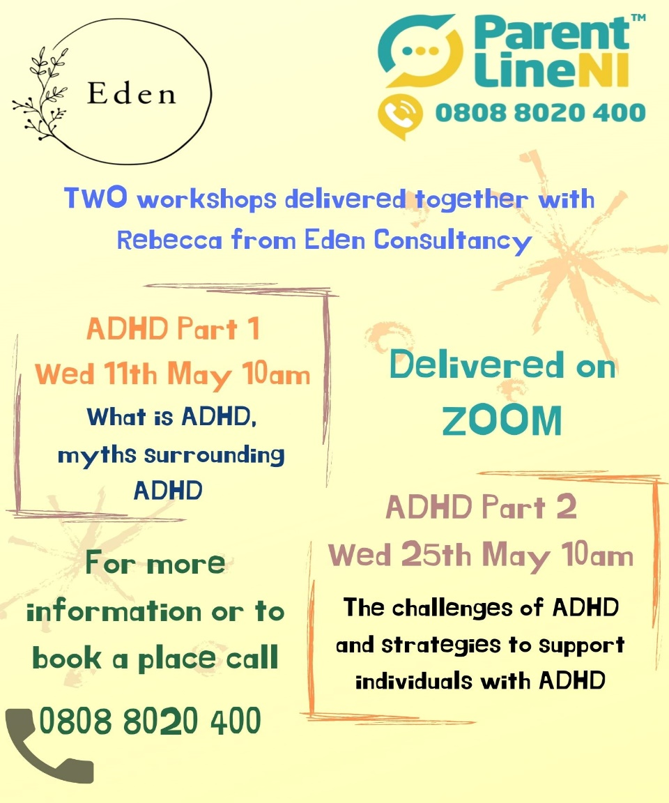
ADHD Support

