**IRVINESTOWN PRIMARY SCHOOL**

|  |  |  |
| --- | --- | --- |
| Principal  **J E Read - B.Ed.,**  **Adv. Dip., PQH (NI)**  Telephone: **028 6862 1408**  Fax: **028 6862 8946**  Description: C:\Users\mbreen195\AppData\Local\Microsoft\Windows\Temporary Internet Files\Content.Outlook\P84BLUI2\Eco-Schools CMYK process.jpg | [Image result for roots of empathy  logo](https://www.google.co.uk/url?sa=i&rct=j&q=&esrc=s&source=images&cd=&cad=rja&uact=8&ved=2ahUKEwim2MKugv3hAhU8TRUIHX6tBGsQjRx6BAgBEAU&url=https://www.ourkidscount.ca/programs/roots-of-empathy/&psig=AOvVaw1ti4RyinnpHpR-NAN116oZ&ust=1556892417392783) | 24 Burfits Hill  Irvinestown  Co Fermanagh  C:\Users\jharron486\AppData\Local\Microsoft\Windows\Temporary Internet Files\Content.Word\Mathletics Crest 1 - Proud to be a Mathetics School.pngBT94 1DY  [Image result for ACCELERATED READING LOGO](https://www.google.co.uk/url?sa=i&rct=j&q=&esrc=s&source=images&cd=&cad=rja&uact=8&ved=&url=https://www.carntallprimaryschool.co.uk/parents-area/accelerated-reader/&psig=AOvVaw2qvlxk9W7B-33ixDpXHrbA&ust=1574782196876927) |

Email - [info@irvinestownps.enniskillen.ni.sch.uk](mailto:info@irvinestownps.enniskillen.ni.sch.uk)

Website - [www.irvinestownps.co.uk](http://www.irvinestownps.co.uk)

**JUNE 2022 NEWSLETTER**

Dear Parents,

We are nearing the end of another school year. Despite what many believe this is an extremely busy time at school, finishing off topics, Sports Day, Trips, Prize Day, Reports etc. We continue to be thankful for all the support we receive from parents.

As we hopefully begin a return to a more normal pattern of school life Mrs Read and I would be grateful if you could take 5 - 10mins to complete a google form to let us know your feelings on some aspects of school life. Please click on this link <https://forms.gle/zNrU239nMfeq9PQN8>

Mrs Read intends to return on a phased basis in the last few weeks of June. Can I just say a big thank you to all of the school community including the Board of Governors, parents, pupils and staff who have been so supportive of me in this temporary position. Thank you!

**JUBILEE DAY CELEBRATION**

The whole school community had a wonderful day of royal celebration in honour of the Queen's Platinum Jubilee. The day was organised by Mrs Gray and the student school council who came together to organise the festivities. There were bouncy castles, and many royal themed games such as pin the tail on the corgi, pin the jewel on the crown and a different scavenger hunt for each key stage!   
Children and staff enjoyed a Royal feast outdoors provided by the kitchen staff, and the pupils also prepared some food for the picnic. There were class performances, each class performing a song from each decade of the Queen's reign and the pupils were delighted when the ice cream van arrived!  
Year 5 have written and posted letters to the Queen to congratulate her on this special occasion. They will eagerly await her reply.  
This was a joyous occasion following a long period of time when pupils could not partake in activities such as this due to COVID-19. The student school council intend to make a time capsule with memories of this momentous occasion to be discovered by pupils in the future.   
Thank you everyone for the wonderful effort you put in. It really was a very special day! I hope you have had the time to look at the photos published on our school website and on your child’s online platform.

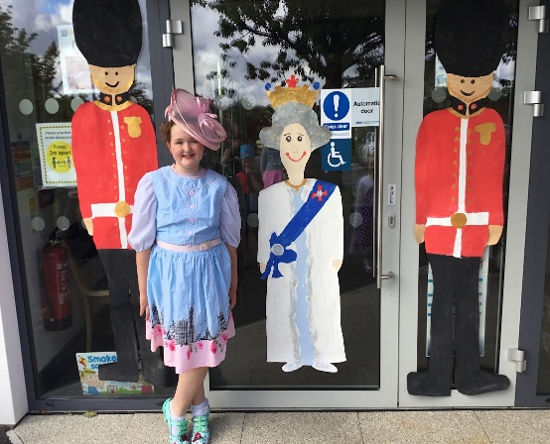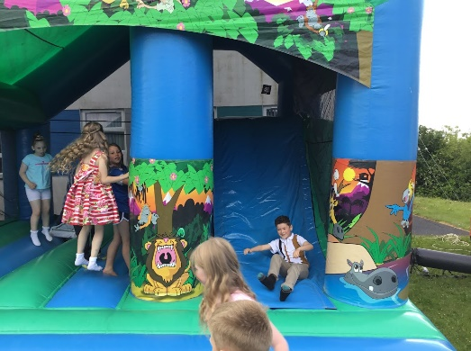

**SPORTS DAY 2022**

We had another fantastic day yesterday for Sports Day. It really was a super day with great weather and fun. Thank you to everyone who came and supported the children. If you were unable to come please have a look at the photos on our school website and/or your child’s online platform.

A special thanks goes to Spar for their sponsorship of the fruit and bottles of water. They also provided participation medals too. Our Prize giving is due to take place today Wednesday 8th June

**CASH FOR CLOBBER**

Thank you for supporting our clothes collection. It raised £104 for school funds.

**SPONSORED BOUNCE**

Thank you to everyone who so generously supported our Sponsored Bounce. We are absolutely delighted with the magnificent total of £ 3320. This will give a much needed boost to our school funds.

**GREEN FLAG**

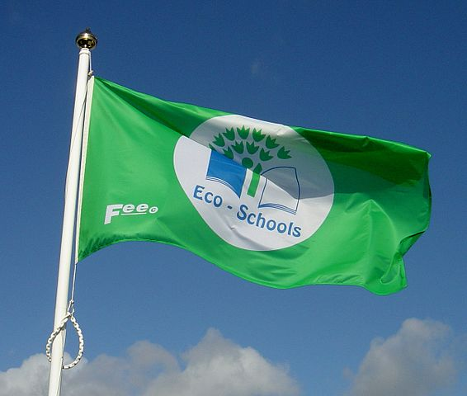

We are delighted to have been awarded our Green Flag status yet again. Mrs Bradshaw and the Eco team have worked hard this year to ensure that our efforts with Eco awareness have not gone unnoticed or unrewarded. Mrs Bradshaw and some members of the Eco team will attend a celebration event in the Bawnacre Centre on Tuesday 14th June

**Y7 BUSINESS BEGINNING PROJECT**

Y7 have been busy taking part in the Business Beginning’s project which involved the children becoming entrepreneurs. The children divided into 4 groups and pitched their ideas to a ‘Dragon’s Den’ panel consisting of Mrs Harron, Mrs Wright and Mrs Bradshaw before a final project was selected to receive financial support from IPS. The winning project was Dazzling Door Hangers and the children have had a fantastic time, planning, making, marketing and selling their product to the whole school community. With their profits they have been able to pay for a trip away to Airtastic on Wednesday 29th June . Thank you to everyone who purchased a hanger. There are still a few more available at a cost of £1.50/£2.00 Congratulations Year 7 on such a fantastic effort.

**MOVING ON**

P7’s have been having lots of transition work in preparation for their big move in September. All have now been made aware of their post primary placement. Mr Alastair McFarland and Mrs Leah Abbott have been in working on the SU ‘It’s Your Move’ transition programme and they have also been working with the Verbal Arts Centre in Londonderry.

A celebration event is to be held on Thursday 16th June for Y7 and their parents. Prizes will be distributed after Year 7 have performed their end of year play. It is hoped that Mrs Read will be able to join us.

**HOUSE TRIP**

Children from the winning house and the Best Boys and Girls from each of the other classes will be going on a surprise end of year trip on Friday 24th June. Thank you to all the children who have been working hard gaining effort points, entering and winning competitions, attending after school clubs and gaining points on Sports Day. To date each house has well over 17000 points each. The children are anxiously awaiting the final result. A letter will be sent out after prize day to let you know if your child’s house has won.

**END OF YEAR TRIPS**

We are delighted to able to organise some trips again. Each class will be going to the beach at Rossnowlagh. Y1/2/3 are going on Tuesday 21st June Y4/5 on Monday 20th June

Y6/7 on Wednesday 22nd June Letters will be sent out to each class.

**BORROWED DEVICES**

Any i-pads / chrome books/ digital devices that were on loan should also be left back by Friday 17th June.

**MILK MONEY**

Milk money for this term is still outstanding for some pupils. Please pay by Monday 13th June, if you have not already done so.

**END OF YEAR TRANSTITION**

All classes will have an opportunity to visit their new classroom and meet their new teacher on the afternoon of Tuesday 28th June.

**FREE SCHOOL MEALS AND UNIFORM CLOTHING ALLOWANCE**

Should you wish to apply for Free School Meals and Uniform, the following website

[www.eani.org.uk/i-want-to/fsm/](http://www.eani.org.uk/i-want-to/fsm/) will provide all you need along with criteria and the process. If you think you are eligible please apply as eligibility for Free School Meals entitles you to other benefits such as uniform allowance, free music tuition, no AQE charge and so on. It also benefits the school financially. You will be able to apply from 6th June 2022.

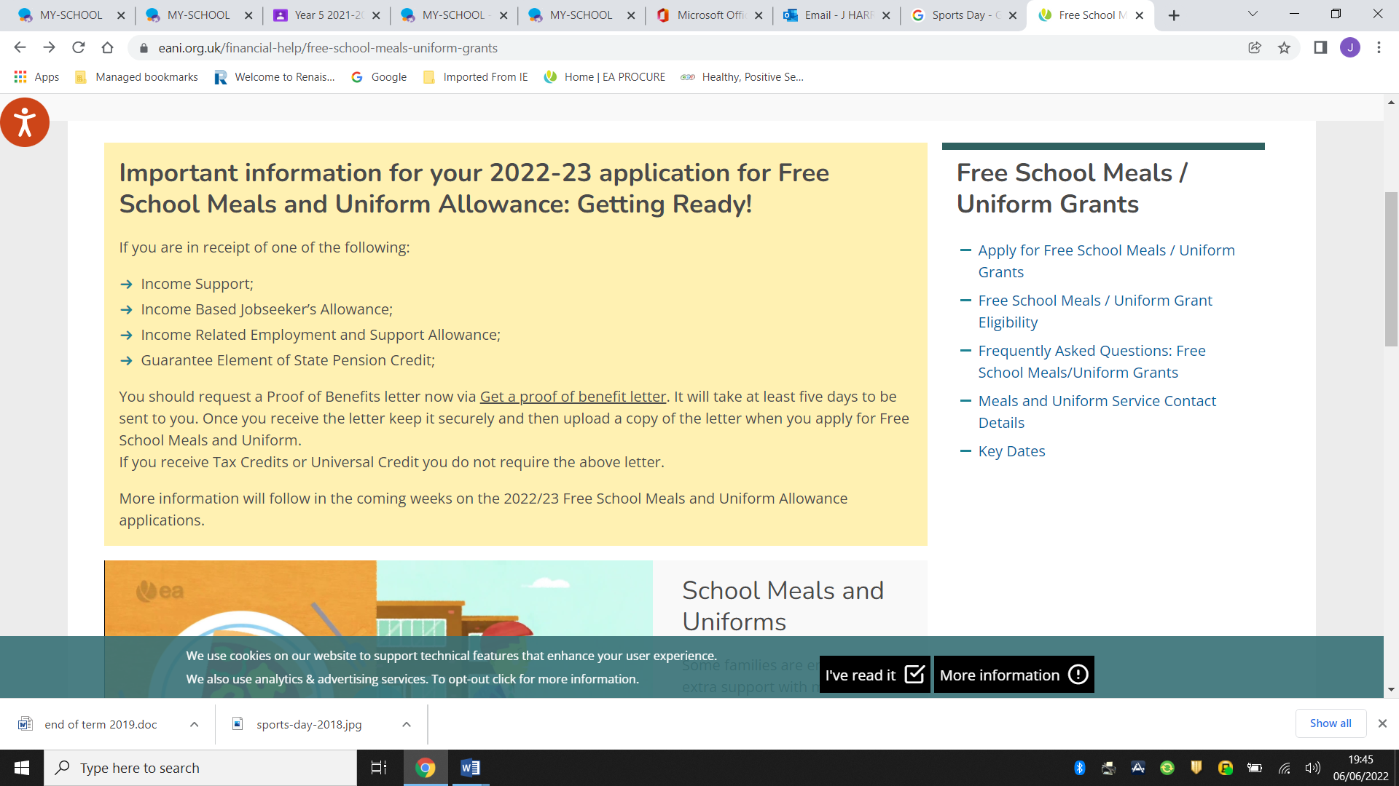

Please note during the peak processing period of June to September it may take up to 6 weeks to process your claim. Please see the timeline below and note that if your application is received after 31st July it may not be processed in time for 1st September.

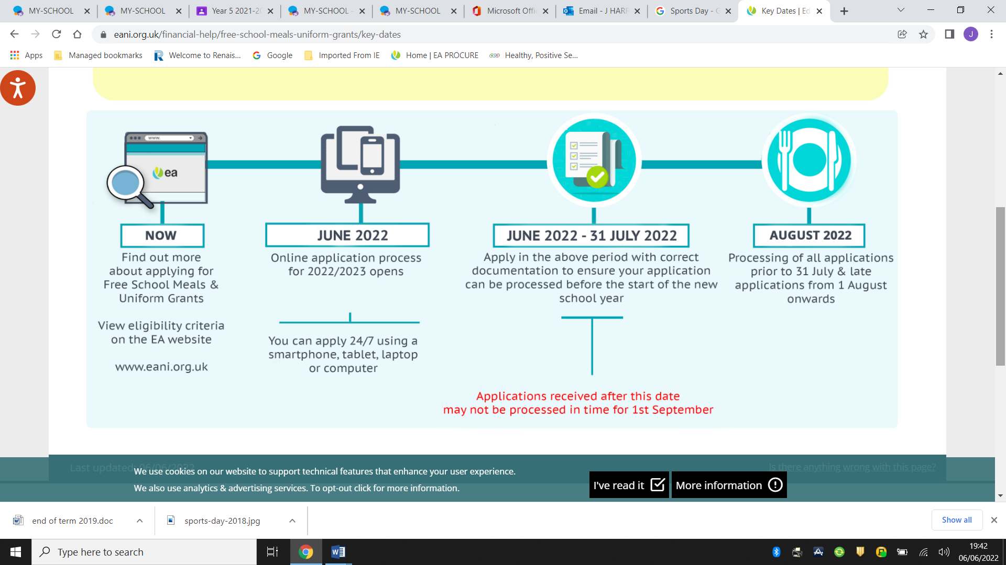

**TRANSPORT APPLICATIONS**

**P1 and P7** applications for transport assistance to all schools, primary and post primary should now be completed online via the EA website at [www.eani.org.uk/transportapp](http://www.eani.org.uk/transportapp)

Eligibility for transport assistance to mainstream schools is based on the distance from the pupil’s home to the school at which they have been offered a place or currently attend. The qualifying distance is two miles or more for Primary, measured by the shortest available walking route door to door.

All transport applications **must** be made online through the EA website. <https://www.eani.org.uk/financial-help/home-to-school-transport>

**AQE/GL TRANSFER TEST**

Enniskillen Royal Grammar and Omagh Academy will be using the AQE test. The dates of the three assessments are Saturday 19th November, Saturday 26th November and Saturday 3rd December 2022 at 10am.

The cost to parents is £60.

Applications opened on **Wednesday 4th May 2022** and will close on **Friday 23rd September at 4pm and are available via this link** [www.aqe.org.uk](http://www.aqe.org.uk)

**Mount Lourdes/St Michael’s College will be using the GL entrance assessment.**

The GL Entrance Assessment will be held on Saturday 12th November 2022.

The Entrance Assessment registration period runs from Wednesday 4th May 2022 until Friday 23rd September 2022 (2:00 pm).

Registration Packs are now available from the website <https://pptcni.com/>

There is no cost for this test.

**CORE KIDS SUMMER CAMPS** 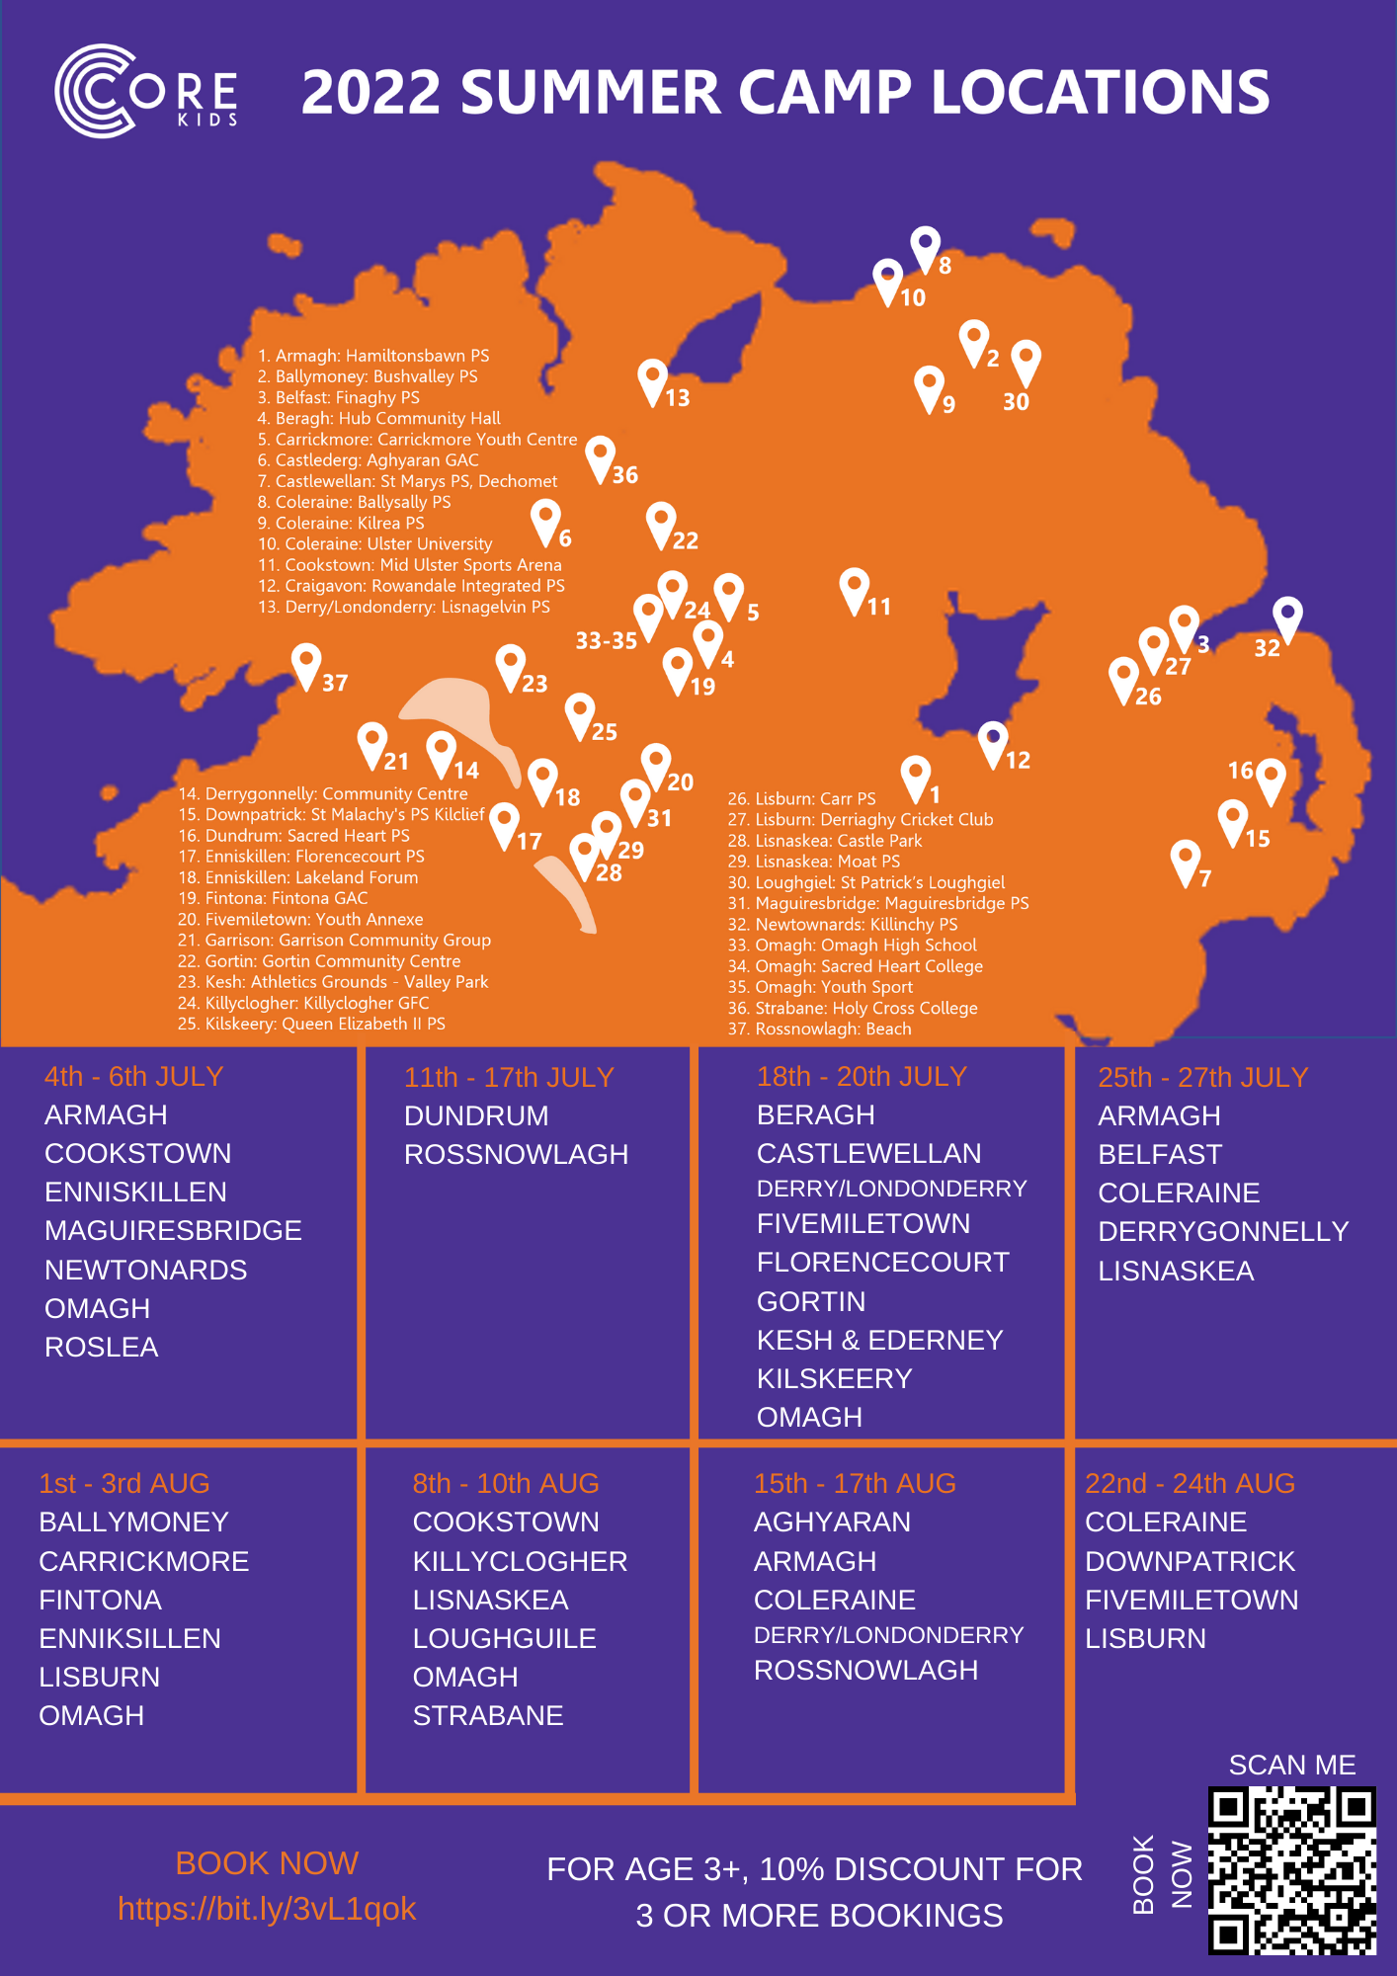

**ARC SUMMER SCHEME**

A separate email has been sent with the application for this year’s ARC summer scheme. If you are interested in applying for your child/ren, the completed forms can be returned to school on or before 17th June 2022

**ON-LINE SAFETY**

**Parents, please, please monitor your child’s on-line use. Children SHOULD NOT be using phones and devices to connect with others without parental supervision. It is important that as a parent you check their phone/messages daily.**

Excellent advice is available from NSPCC and many other places – some of which are listed below.

<https://www.nspcc.org.uk/keeping-children-safe/online-safety/internet-connected-devices/>

<https://www.saferinternet.org.uk/advice-centre/parents-and-carers/parents-guide-technology/tablets>

<https://www.internetmatters.org/schools-esafety/parent-online-support-pack-teachers/>

It is also worth considering that Youtube is recommended for 18 year olds. It should never be used unsupervised as it has a lot of adult material that can easily be accessed. Please use the kids YouTube version which has built in controls. <https://www.youtube.com/intl/ALL_uk/kids/>

The kids version of google is <https://www.kiddle.co/>

Please note the age restrictions for social media below- children in Primary school should not be in a what’s app group – recommended for 16 years – nor should they have their own Youtube account.

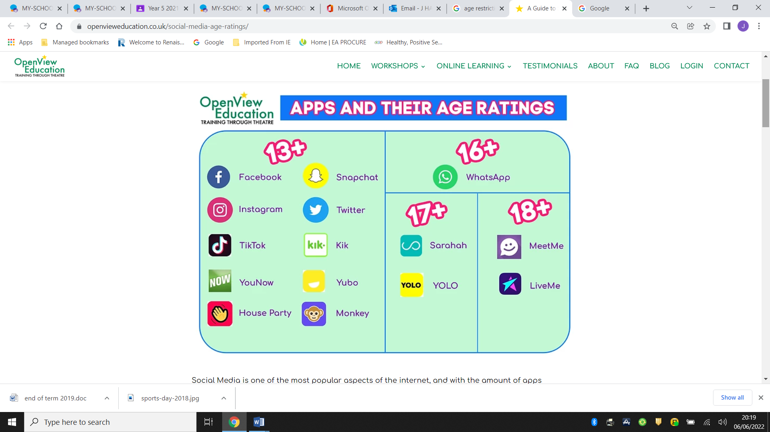

The safer schools app has excellent advice on how to set up parental controls etc. on your child’s phone. <https://oursafetycentre.co.uk/safetysettings/>

Parentline NI would like to remind you all that their Regional Parents Helpline is in full operation. They can be contacted on freephone 0808 8020 400 to provide advice, support and guidance to parents and carers.

Monday- Thursday 9am-9pm

Friday 9am-5pm

Saturday 9am-1pm

You can also contact them via webchat www.ci-ni.org.uk or email parentline@ci-ni.org.uk

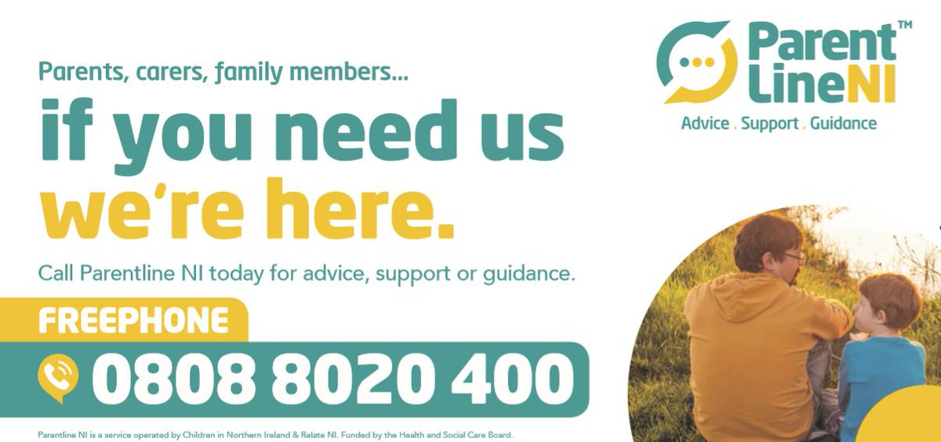

**END OF YEAR ARRANGEMENTS**

School will close at lunch time on Thursday 30th June.

We will be dismissing the children at these times to aim to reduce congestion.

* Year 1 and their siblings will be dismissed from the pick-up point at the

front as usual at 12.00 p.m.

* Year 2 and their siblings will be dismissed from the pick-up point at the

front as usual at 12.10 p.m.

* Year 3 and their siblings will be dismissed from the pick-up point at the

front as usual at 12.20 p.m.

* Years 4-7 should be collected at 12.30 p.m. from the pick-up point at the front.

**To adhere to the social distancing rules please remain in your car and do not come before the allocated time.**

Ensure the person collecting your child is aware of these arrangements- i.e. grandparents/childminder. Please adhere to the allocated times.

EA transport will NOT be available. It is your responsibility to ensure your childcare provider i.e. Active Allsorts / Treetops is available to collect at this time.

Have a relaxing and restful Summer holiday. I wish our Year 7 Leavers every success and happiness in their new schools and look forward to welcoming the new Year 1 entrants and all our pupils back in the new term.

Yours Sincerely,

**Janice Harron**

J Harron (Mrs)

Acting Principal

**Dates for the Diary**

|  |  |  |  |  |
| --- | --- | --- | --- | --- |
| **6** | **7** | **8** | **9** | **10** |
| Staff Training | Sports Day | Devenish/ERGS/Omagh Academy to see Y7  Y1/2 go home at 1pm for DELTA afternoons | Musical Pathways Y1-4  Verbal Arts Y7 |  |
| **13** | **14** | **15** | **16** | **17** |
|  | Y6 Friends for Life  ECO Flag presentation | Y1/2 go home at 1pm for DELTA afternoons | PRIZE DAY Y7 |  |
| **20** | **21** | **22** | **23** | **24** |
| Y6/7 First Aid Training  Y4/5 Beach trip | Y1/2 Beach trip | Y6/7 Beach Trip  Y1/2 go home at 1pm for DELTA afternoons | Y7 Induction days at their new school | Winning House Trip |
| **27** | **28** | **29** | **30** |  |
|  | Orientation afternoon to meet new teacher. | Y7 Airtastic Trip 9.15-4pm | School ends 12-12.30 |  |

**PRO FORMA**

**P1-P7**

I will collect/organise collection of ________________________(name of child)

from school on the last day of term (30th June) at the allocated time

between 12 – 12.30pm.

Signed ____________________________ (Parent)

**IRVINESTOWN PRIMARY SCHOOL**

|  |  |  |
| --- | --- | --- |
| Principal  **J E Read - B.Ed.,**  **Adv. Dip., PQH (NI)**  Telephone: **028 6862 1408**  Fax: **028 6862 8946**  HPSA[1]Description: C:\Users\mbreen195\AppData\Local\Microsoft\Windows\Temporary Internet Files\Content.Outlook\P84BLUI2\Eco-Schools CMYK process.jpg |  | 24 Burfits Hill  Irvinestown  Co Fermanagh  BT94 1DY  C:\Users\jharron486\AppData\Local\Microsoft\Windows\Temporary Internet Files\Content.Word\Mathletics Crest 1 - Proud to be a Mathetics School.png [Image result for ACCELERATED READING LOGO](https://www.google.co.uk/url?sa=i&rct=j&q=&esrc=s&source=images&cd=&cad=rja&uact=8&ved=&url=https://www.carntallprimaryschool.co.uk/parents-area/accelerated-reader/&psig=AOvVaw2qvlxk9W7B-33ixDpXHrbA&ust=1574782196876927) |

Email - [info@irvinestownps.enniskillen.ni.sch.uk](mailto:info@irvinestownps.enniskillen.ni.sch.uk)

Website - [www.irvinestownps.co.uk](http://www.irvinestownps.co.uk)

**SCHOOL CLOSINGS 2022 - 2023**

**AUTUMN TERM**

Term Begins 1st September 2022

Half Term 31st October, 1st, 2nd November

Staff Training 3rd, 4th November

Last Day of Term 21st December

**SPRING TERM**

Staff Training 5th January 2023

Term Begins 6th January

Half Term 16th & 17th February

Staff Training 20th February

St Patrick’s Day Holiday 17th March

Last Day of Term 4th April

**SUMMER TERM**

Term Begins 18th April

Early May Bank Holiday 1st May

Late May Bank Holiday 29th May

Staff Training 5th June

Last Day of Term 30th June

**On Last Day of Each Term**

**School Closes at 12.00(Y1 & Y2) & 12.30pm (Y3 - Y7)**

**Staff Training Days - School Closed**